Assignment-OS

Unit-06 Input Output Management

- Compare I/O based on polling with interrupt-driven I/O. In what 04 situation any one technique is preferable over the other?

Polled I/O processor continually checks I/O device to see if it is ready for data transfer.

It is inefficient, processor wastes time checking for ready condition. It either checks too often or not often enough.

Interrupt driven I/O:- I/O device interrupts processor when it is ready for data transfer.

Here the processor can be doing other task while waiting for last data transfer to complete.

It is very efficient. Alll I/o in modern computers is interrupt driven.

- Explain operation of DMA transfer with proper diagram.

The data transfer between a fast storage media such as magnetic disk and memory unit is limited by the speed of CPU. Thus we can allow the peripherals directly communicate with each other using the memory buses , removing the intervention of CPU. This type of data transfer is known as Director Memory Access (DMA).
During DMA the CPU is idle and it has no control over the memory buses. The DM controller takes over the buses to manage the transfer directly between the I/O devices an the memory unit.
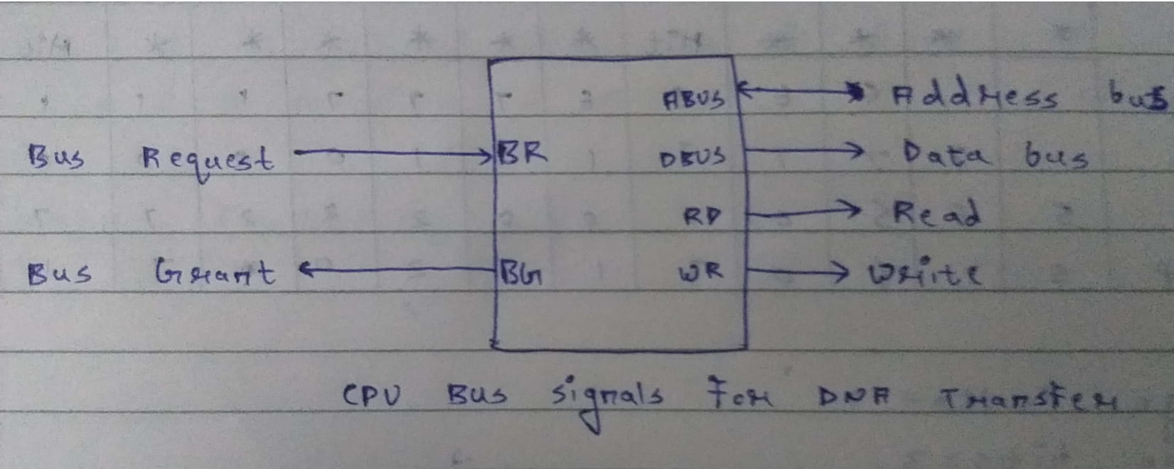

Bus Request: Used by the DMA controller to request the CPU to relinguish the control of Buses. Bus Grant:-

Its activated by the CPU to inform the external DMA controller that the buses are in high impedance state and the requesting DMA can take control of the buses.

- Explain principal of I/O software.

The principles of I/O software are :-
(a) Device Independence :- I/O devices should be accessible to program without
specifying the device in advance.
(b) Uniform Naming :- In Unix, all disks can be integrated in the file system hierarchy
in arbitrary ways so the user need not to be aware of which name corresponds to
which device.
(c) Error Handling:- If the controller discovers a read error, it should try to correct the error itself if it can. If it cannot than the device driver should handle it.
(d) Synchronous and Asynchronous transfers:- Most physical I/O is asynchronous,
however some very high-performance applications need to control all the details of the I/O, so asynchronous I/O is made available to them.
(e) Bufffering :- Often data that come off a device cannot be stored directly in their final destination.

- Explain the use of Controller in I/O transfer.

An I/O controller connects input and output devices to the bus system of a central
processing unit. It typically communicate with the CPU and with the system memory over
the system bus and can control many devices. Control is usually initiated by the CPU, and signals attached to it should be handled.

- What is called device driver? Explain its function in brief

More commonly known as a driver, a device driver or hardware driver is a group of files
that enable one or more hardware devices to communicate with the computer’s operating
system. Without drivers, the computer would not be able to send and receive data correctly
to hardware devices, such as printers. Hardware devices that are unknown by the operating
system all require drivers. If the appropriate driver is not installed, the device may not function properly.

- What is RAID? Explain in brief.

RAID stands for “Redundant Arrays of Independent Disks “ , it is a technique whuch makes use of a combination of multiple disks instead of using a single disk for increased performance, data redundancy or both.
Key evaluation points for a RAID system:
(a) Reliability: How many disk faults can the system tolerate.
(b) Availabilty: What fraction of the total session time is a system in uptime mode.
(c) Performance: How good is the response time.
(d) Capacity; Given a set of N disks each with B blocks , how much useful capacity is available to the user.
To the host system , RAID appears as a single big disk presenting itself as a linear array of blocks.

- Explain various Disk Arm Scheduling Algorithms with illustration.

Various Disk scheduling algorithms are:-

- FCFS:- Here the requests are addressed in the order they arrive in the disk queue.

Advantages: Every requests gets a fair chance and no indefinite postponement.

Disadvantages: Doesn’t try to optimize seek time and may not provide the best possible service.

- SSTF(Shortest Seek Time First):- Requests having shortest seek time first. So the seek time of every request is calculated in advance in the queue and then they are scheduled according to their seek time.

Advantages: Average response time decreases and throughput increases.

Disadvantages: Overhead to calculate seek time in advance and high variance of response time as SSTF favours only some requests.

- SCAN:- Here the disk arm moves in a particular direction and serves the requests coming in its path and after reaching the end of the disk it reverses its direction. Advantages: High throughput and average response time.

Disadvantages: Long waiting time for requests.

- CSCAN:- In CSCAN algorithm, the disk arm instead of reversing its direction goes to the other end of the disk and starts servicing the requests from there. Advantages: Provides more uniform wait time compared to SCAN.

- LOOK:- It is similar to SCAN, except for the difference that the disk arm inspite of going to the end of the disk goes only to the last request to be serviced infront of the head and then reverses its direction from there only. It prevents the extra delay occurred due to unnecessary travel.

- CLOOK:- CLOOK is similar to CSCAN , here the disk arm inspite of going to the end goes only to the last request to be serviced infront of the head and from these goes to the other ends last request. Hence it also prevents the extra delay which occurs due to unnecessary traversal.

- Explain RAID level system.

The RAID levels are:-

- RAID LEVEL 0:

Stripes data occurs two or more drives. No parity. RAID 0 gives good read/write performance but doesn’t provide data redundancy. All data will be lost if one disk fails. RAID 0 should only be used if you can accept data being inaccessible during a drive failure while you restore if from other media.

- RAID LEVEL 1:

Mirrors data to two or more drives. No parity. Having multiple drives with identical data gives high availability in terms of read performance and boosts data protection.

As long as one drive of a mirrored pair doesn’t fail, no data is lost. Duplicating drives brings a cost issue.

- RAID LEVEL 0+1:

Striped sets in a mirrored set. It creates a striped set that mirrors a primary striped set. The array will continue to operate if one or more drives in the same mirror set fail. But if drives in both mirror set fails, all of the data will be lost. A minimum of four disks are there and even number of disks in a mirrored set.

- RAID LEVEL 1+0:

A mirrored set in a stripped set. If disks fail RAID 1+0 performs better than RAID 0+1 because all of the remaining disks are still in use. The array can suffer multiple drive failures as long as no mirror set loses all of its drives.

- RAID LEVEL 3:

Byte level striping with a dedicated parity disk. With a dedicated parity disk can tail and the remaining data will continue to be accessible. The dedicated parity disk must be written to each time data is updated.

(6) RAID LEVEL 4:

Block level striping with a dedicated parity disk. Its similar to RAID 3, except random access is improved with block level striping.

(7) RAID LEVEL 5:

Striping with distributed parity. No dedicated parity disk. It needs all drives but one to be operating. The array doesn’t fall completely if a single disk is destroyed, but will upon a second drive failure.

(8) RAID LEVEL 6:

Striping with dual distributed parity. Distributed parity gives fault tolerance against two drive failures. Dual parity means that while a failed disk being rebuilt the array is still protected by the remaining parity data.

(9) What are the use of device driver & controller in OS? Explain.

REPEATED.

(10) Explain Device Independent I/O software.

The functions of device independent I/O softwares are:-
A major issue of an OS is that there is no standard interfacing for device drivers.
A device independent I/O software aims at providing same interface for all device drivers, as shown below. Now it becomes easier to plug in a new driver.

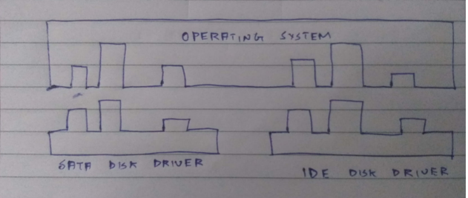

(2)Buffering:
It is a issue both for block and character devices.
Buffer in users pace:- Here user process provides an n-character buffers in user space and does a read of n-characters.
Buffer inside kernel:- To create the buffer inside the kernel and interrupt handler is responsible to put the character there.
Two buffers in the kernel:- The first buffer is used to store characters. When it is full it is being copied to user space. During that time the second buffer is used.

(3)Error reporting:

One class oof I/O errors is programming errors. These occur when a process asks for something impossible, such as writing to an input device or reading from an output device. The action taken is to report these errors back to the caller.

(4)Allocating and releasing dedicated devices:

A mechanism for requesting and releasing dedicates devices is required. An attempt to acquire an already occupied device is blocked instead of failing. Blocked processes are put on a queue.

(5)Device independent block size:

Different disks have different sector sizes. Its upon the device independent I/O software to hide this fact and provide a uniform block size to higher layers.

11) Compare the performance of write operations achieved by a RAID level 04 5 organization with that achieved by a RAID level1 organization.

RAID level 1 organization can perform writes by simply issuing writes to mirrored data concurrently. RAID level 5 on the other hand, would require the old contents of the parity block to be read before it is updated based on the new contents of the target block. This results in more overhead for the write operations on a RAID level 5 system.

12) Suppose that a disk drive has 5,000 cylinders, numbered 0 to 4999. The 12 drive is currently serving a request at cylinder 143, and the previous request was at cylinder 125. The queue of pending requests, in FIFO order, is:

86,1470,913,1774,948,1509,1022,1750,130

Starting from the current head position, what is the total distance (in cylinders) that the disk arm moves to satisfy all the pending requests for each of the following disk-scheduling algorithms?

(a) FCFS
The FCFS schedule is:-
143, 86, 1470, 913, 1774, 948, 1509, 1022, 1750, 130.
Total seek distance = |143-86| + |86-1470| + |1470-913| +|913-1774| + |1774-948|

+|948-1509| + |1509-1022| + |1022-1750| + |1750-130| = 57+1384+557+861+826+561+487+728+1620 =7081

(b) SSTF
The SSTF schedule is:-
143, 130, 86, 913, 948, 1022, 1470, 1509, 1750, 1774.

Total seek distance = |143-130| + |130-86| + |86-913| +|913-948| + |948-1022| + |1022-1470| + |1470-1509| + |1509-1750| + |1750-1774|

= 13+44+827+35+74+448+39+241+24 =1745

(c) SCAN
The SCAN schedule is:-
143, 913, 948, 1022, 1470, 1509, 1750, 1774, 4999, 130, 86.

Total seek distance = |143-913| + |948-913| + |948-1022| + |1022-1470| + |1470-1509| + |1509-1750| + |1750-1774| + |1774-4999| + |4999-130| + |130-86|

= 770+35+74+448+39+241+24+3225+4869+44 =9769

(d) LOOK
The LOOK schedule is:-
143, 913, 948, 1022, 1470, 1509, 1750, 1774, 130, 86.

Total seek distance = |143-913| + |913-948| + |948-1022| +|1022-1470| + |1470-1509| + |1509-1750| + |1750-1774| + |1774-130| + |130-86|

= 770+35+74+448+39+241+24+1644+94 =3319
(e) CSCAN
The CSCAN schedule is :-
143, 913, 948, 1022, 1470, 1509, 1750, 1774, 4999, 86, 130.

Total seek distance = |143-913| + |913-948| + |948-1022| +|1022-1470| + |1470-1509| + |1509-1750| + |1750-1774| + |1774-4999| + |4999-86| + |86-130|

= 770+35+74+448+39+241+24+3225+4913+44 =9813

(f) CLOOK
The CLOOK schedule is :-
143, 913, 948, 1022, 1470, 1509, 1750, 1774, 86, 130.

Total seek distance = |143-913| + |913-948| + |948-1022| +|1022-1470| + |1470-1509| + |1509-1750| + |1750-1774| + |1774-86| + |86-130|
=770+35+74+448+39+241+24+1688+44
=3363

13) Given a hard disk of 200 tracks (Track 0-199) with Track 0 being the 10 innermost track. Write down the track numbers the disk head will travel for the following 5 disk scheduling algorithms with the following sequence of disk track requests: 103, 110, 95, 130, 143, 55, 50, 147, 40. The disk head has just finished a request at track 105 and is currently at track 100. For this exercise, which disk-scheduling algorithm (FIFO, LIFO, SSTF, SCAN, C-SCAN) is most effective?

(a) FIFO
The FIFO schedule is:-
100, 103, 110, 95, 130, 143, 55, 50, 147, 40.

Total seek distance = 3+7+557+15+35+13+5+97+107 =370

(b) LIFO
The LIFO schedule is:-
100, 40, 147, 50, 55, 143, 130, 95, 110, 103.

Total seek distance = 60+107+97+5+88+13+35+15+7 =427

(c) SSTF
The SCAN schedule is:-

100, 103, 110, 95, 130, 143, 147, 55, 50, 40. Total seek distance = 3+7+15+35+13+4+92+5+10 =184

(d) SCAN
The SCAN schedule is:-
100, 103, 110, 130, 143, 147, 199, 95, 55, 50, 40.

Total seek distance = 3+7+20+13+4+52+104+40+5+10 =258

(e) CSCAN
The CSCAN schedule is :-

100, 103, 110, 130, 143, 147, 199, 40, 50, 55, 95. Total seek time = 3+7+20+13+4+52+159+10+5+40 =313

The most effective algorithm is SSTF.

14) Suppose that a disk drive has 5000 cylinders, numbered 0 to 4999. The 10 drive is currently serving a request at cylinder 163, and the previous request was at cylinder 115. The queue of pending requests, in FIFO order, is 186, 2460, 513, 1764, 942, 509, 1122, 1250, 1260. Starting from the current head position, what is the total distance (in cylinders) that the disk arm moves to satisfy all the pending requests, for each of the following disk scheduling algorithms?

a. FCFS

The FCFS schedule is:-

163, 186, 2460, 513, 1764, 942, 509, 1122, 1250, 1260.

Total seek distance = 23+2274+1947+1251+822+433+613+128+10 =7501

b. SSTF

The SSTF schedule is:-

163, 186, 509, 513, 942, 1122, 1250, 1260, 1764, 2460. Total seek distance =23+323+4+429+180+128+10+504+696 =2297

c. SCAN

The SCAN schedule is:-
163, 186, 509, 513, 942, 1122, 1250, 1260, 1764, 2460, 4999.

Total seek distance = 23+323+4+429+180+128+10+504+696+2539 =4836

d. LOOK

The LOOK schedule is:-

163, 186, 509, 513, 942, 1122, 1250, 1260, 1764, 2460.
Total seek distance = 23+323+4+429+180+128+10+504+696 =2297

e. C-SCAN

The CSCAN schedule is:-
163, 186, 509, 513, 942, 1122, 1250, 1764, 2460, 4999.

Total seek distance = 28+323+4+429+180+128+10+504+696+2539 = 4836

